

Software Development & Construction
Final Project Report

Group Information

Group Number
9

Group Members
Muhammad Umar Younas (BSSE23043)
Manal Rana (BSSE23099)

Report Content

PROJECT PROPOSAL, EXECUTIVE SUMMARY & PROBLEM DEFINITION

Executive Summary
This project addresses the inefficiencies and limitations of traditional library management systems by developing a cloud-based library management system. The current reliance on paper records and local software results in slow operations, high risk of data loss, and restricted access, affecting both staff and users.
The proposed solution automates manual library tasks, including catalog management, borrowing, and returns, while ensuring secure user data protection. The system leverages AWS cloud architecture, utilizing services such as EC2 for backend hosting, S3 for secure data storage, and AWS SNS for notifications. This ensures scalable, flexible, and always-available access to library resources from anywhere, at any time.
Key outcomes of the implementation include:
- Improved efficiency through automation of routine tasks
- Enhanced security and reduced risk of data loss
- Remote access for staff and patrons, enabling flexible library operations
- Reliable performance supported by AWS infrastructure
By migrating to a cloud-based system, the library achieves a modern, robust, and secure platform that addresses real-world challenges while supporting future scalability and growth.

Introduction
The modern academic and public library environment demands efficient, secure, and accessible management of resources. Traditional methods, such as paper-based cataloging and locally-installed software, no longer meet the expectations of users who require real-time access to library services from anywhere. With the rise of cloud computing, libraries can leverage scalable, secure, and flexible solutions to improve workflow automation, data protection, and operational efficiency.
A cloud-based library management system provides a centralized platform where all library operations—including cataloging, borrowing, returning, and user account management—are automated. This system ensures secure storage of user data, reduces the risk of data loss, and enables staff and patrons to access resources remotely. The system is particularly relevant in environments where low computer literacy and insufficient maintenance practices have traditionally hindered efficiency. By adopting cloud architecture, libraries can overcome these challenges and provide reliable, flexible, and secure services.

Problem Statement
Traditional library management methods, relying on paper-based systems and local software installations, are highly inefficient and prone to significant risks. Paper records are vulnerable to loss, damage, and unauthorized access, leading to compromised data security. Local software systems restrict access to library resources to office premises, preventing users and staff from remotely accessing essential data. These limitations reduce operational efficiency, flexibility, and timely decision-making. Additionally, poor maintenance practices, low computer literacy among staff, and lack of commitment from management exacerbate the problem, making it difficult to maintain accurate records and provide seamless library services. A robust, accessible, and secure system is required to address these challenges effectively.

Aim & Objectives
- Deploy a cloud-based library management system using AWS EC2 and RDS, enabling centralized, reliable, and scalable backend and data storage.
- Automate manual library tasks such as book cataloging, borrowing, and returns, using Node.js backend with API endpoints to reduce human errors and processing.
- Ensure secure user data protection with AWS RDS, ensuring all user credentials and sensitive data are encrypted at rest and in transit.
- Enable anytime, anywhere access for library staff and users through a web-based frontend hosted on EC2, supporting responsive access over HTTP from any location.
- Deploy a user friendly and simple UI so that non technical people and less computer literate people can use the system with ease.
- Make use of user friendly AWS server maintenance so that less computer literate people can maintain the servers easily.

AWS ARCHITECTURE DESIGN, IMPLEMENTATION STEPS & SCREENSHOTS

AWS Architecture Diagram
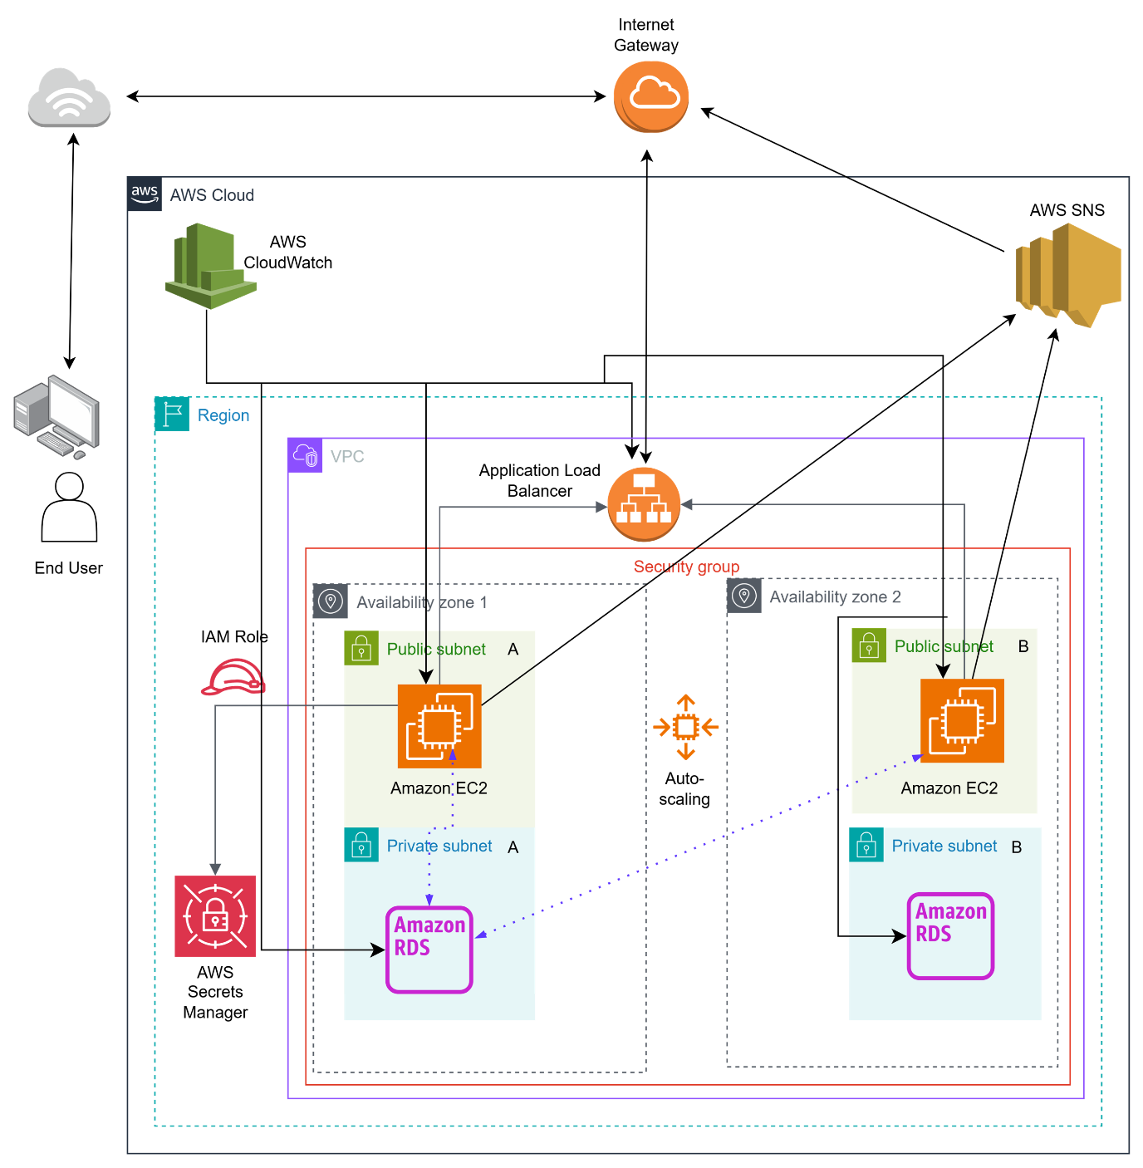

Implementation Steps
- AWS Account Setup
- IAM Roles & Policies

Roles
We used the default IAM role called LabRole
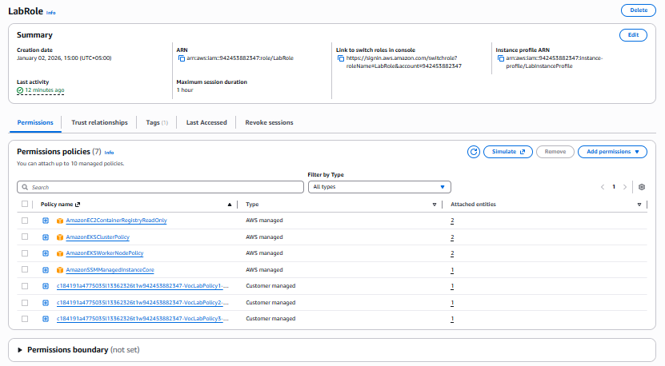

Policies
All the policies attached to LabRole were used

- VPC/Subnets/Security Groups

VPC & Subnets
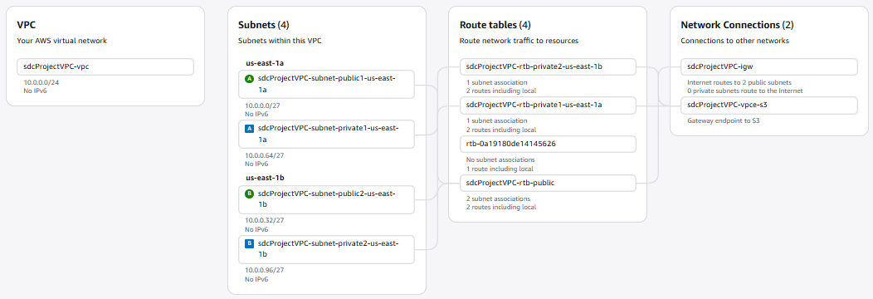

1 VPC “sdcProjectVPC” was created and 4 subnets were attached, 2 public subnets and 2 private subnets, both the public subnets were attached to internet gateway through route tables, the internet gateway was allowing traffic to flow from the public internet.

Security Groups
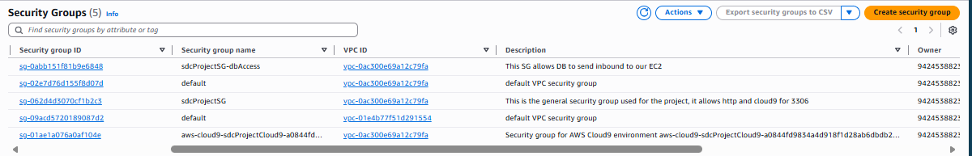
2 main security groups are created and used, “sdcProjectSG” is used by all EC2 instances of the project and “sdcProjectSG-dbAccess” is used by all the RDS instances of the project.

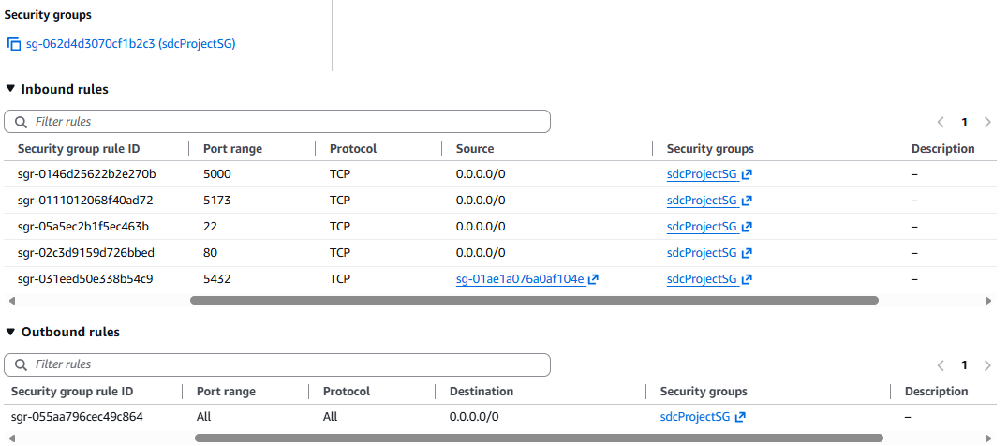
“sdcProjectSG” allows inbound connections to
Public Internet for Project’s backend port (Node.js)
Public Internet for Project’s frontend port (Node.js)
Public Internet for RDS Postgres SQL database
Public Internet for SSH into EC2 instances
Public Internet for RDS Postgres Database

“sdcProjectSG” allows outbound connections to
All sources

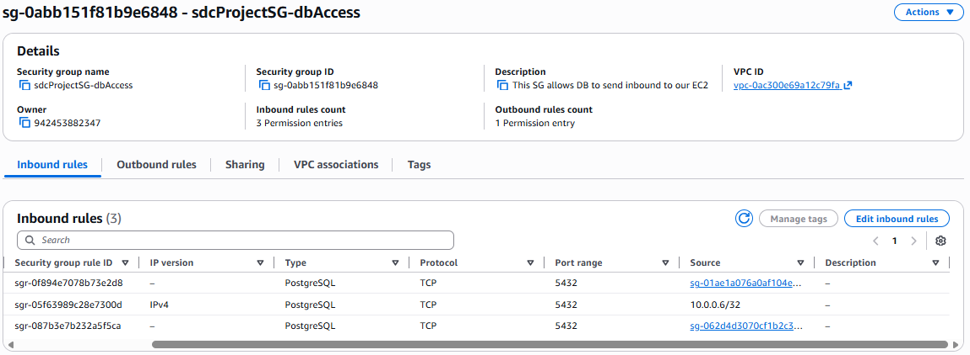
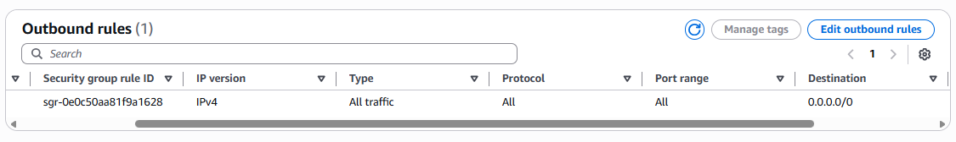
“sdcProjectSG-dbAccess” allows inbound connections to
Cloud9 for RDS Postgres Database
EC2 instances for RDS Postgres Database

“sdcProjectSG-dbAccess” allows outbound connections to
All sources

- AWS Services
- AWS EC2
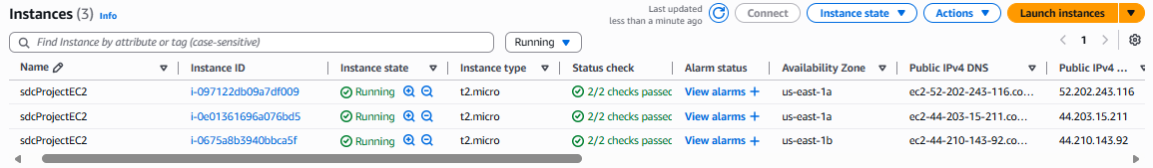
We are using minimum 2 auto scaled EC2 instances that all hold both the code for frontend and backend of our react application

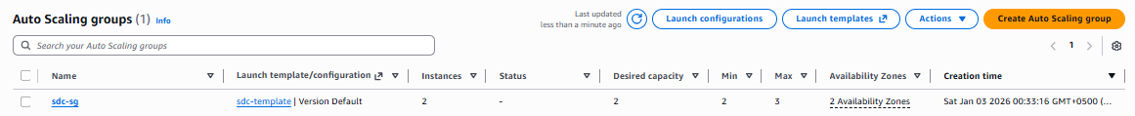
Auto Scaling is applied on the EC2 instances, providing 2 EC2 instances at a minimum, 3 EC2 instances at a maximum and 2 EC2 instances as desired quantity.

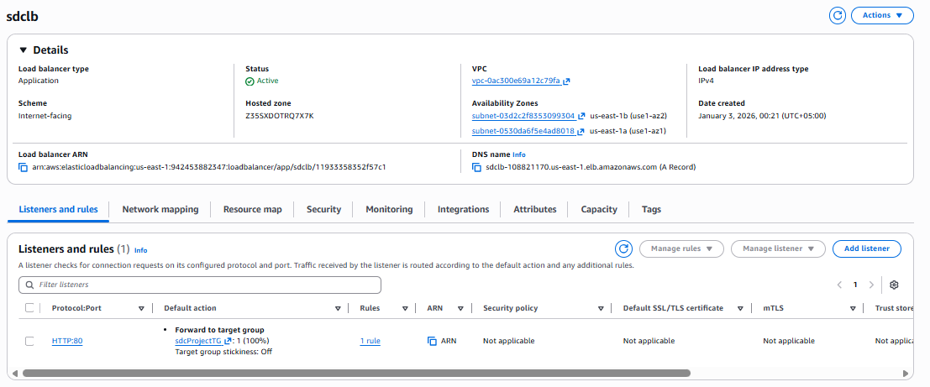
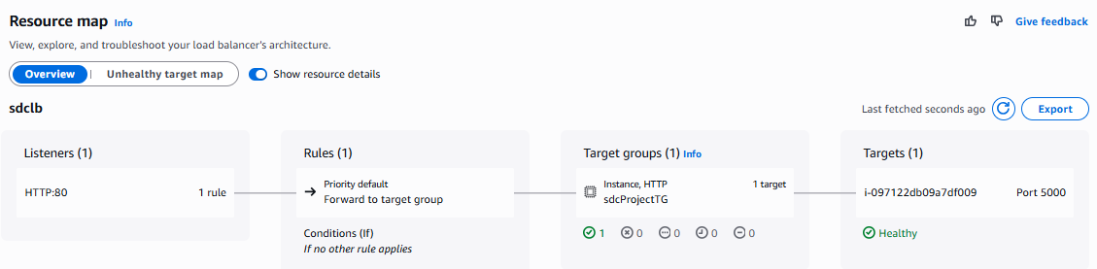We are applying load balancer “sdclb” on our EC2 instances, it balances the load among two availability zones.

- AWS RDS (Relational Database Service)
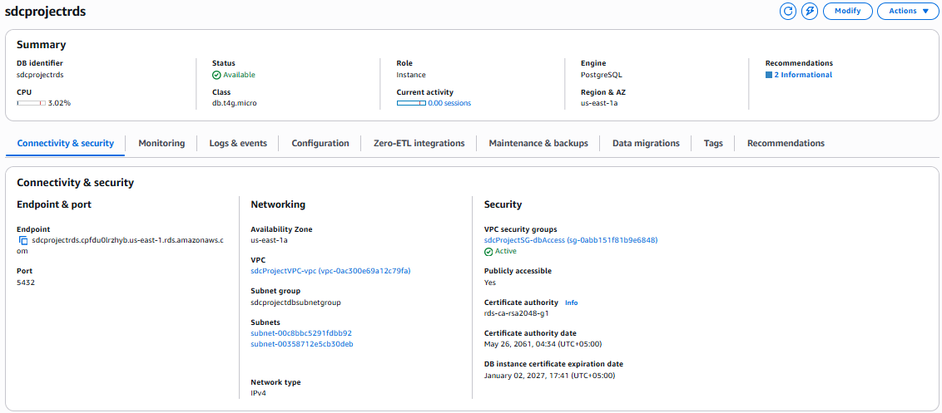
We are using AWS RDS Postgres Instance, which is Single-AZ
Two RDS instances are hosted on the 2 private subnets

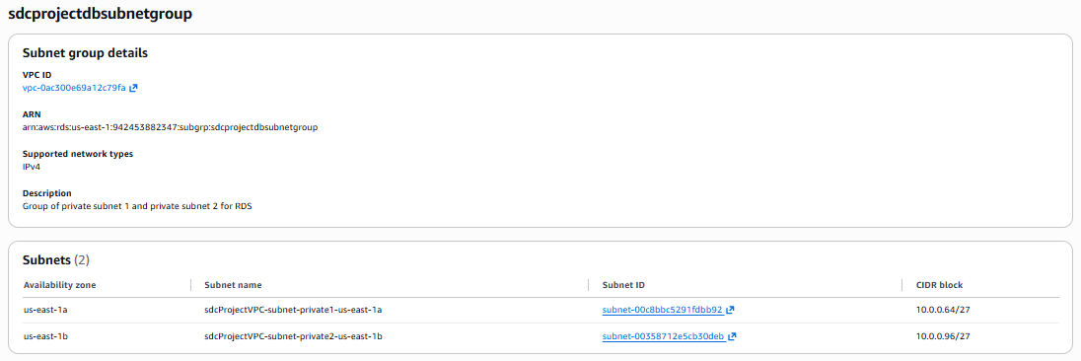
The 2 public subnets are grouped in a single subnet group called “sdcprojectsubnetgroup”
- AWS SNS(Simple Notification Service)

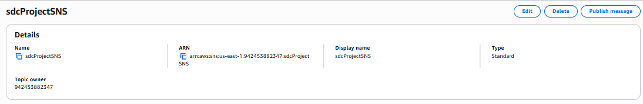
We are using AWS SNS for handling notification system in the project.
There is 1 topic created in SNS “sdcProjectSNS”

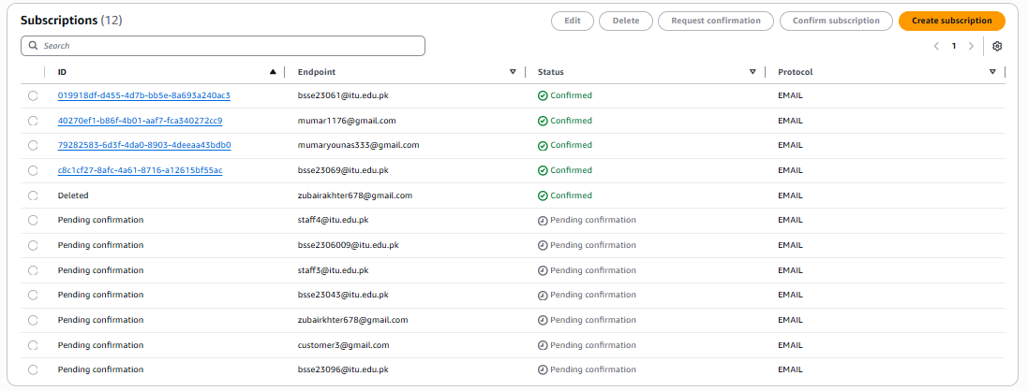
All the subscriptions for this topic are created through aws-sdk functions for SNS used in our Node.js code
All the subscriptions are of EMAIL type

- Deployment Process
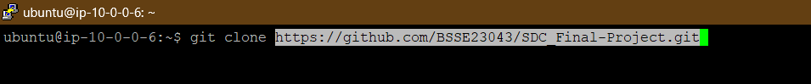
We connected to our EC2 instance using Putty and then cloned our GitHub repository there

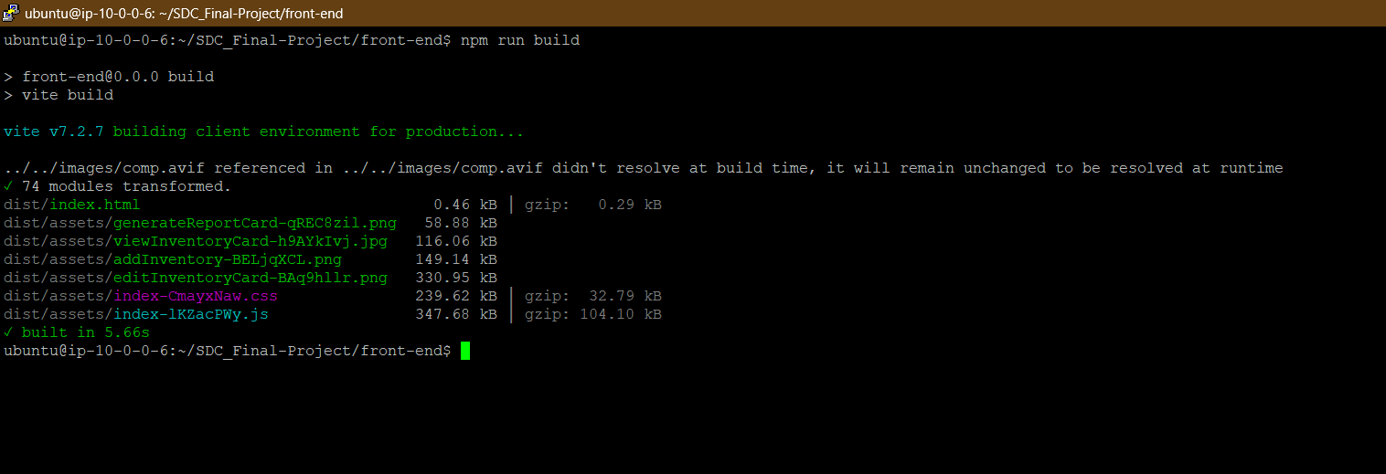
We created a build of our frontend side inside the EC2
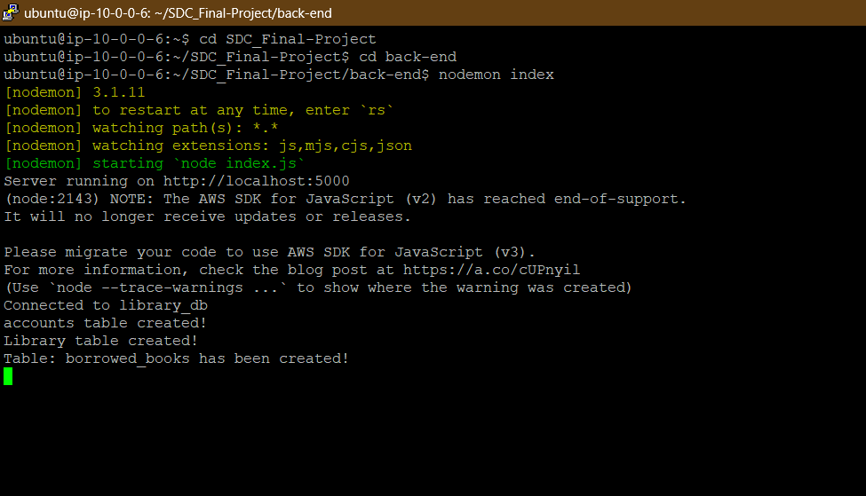
Then we accessed our backend to start the server, the backend automatically serves the frontend side

- Testing workflow
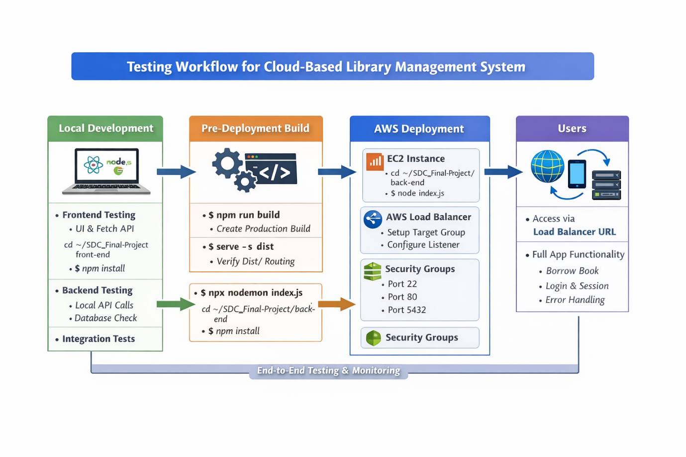

1. Local Development Testing
Frontend Testing
I started the React development server using npm run dev. I verified that all UI components rendered correctly. I tested forms, buttons, navigation, and dynamic content, like loading the book catalog and clicking the borrow button. I made sure all API fetch calls were pointing to my local backend (http://localhost:5000).
Backend Testing
I started the backend server using nodemon index.js. I tested all REST endpoints
- /auth/login and /auth/signup
- /book/viewBookCatalog
- /book/borrowBook
I verified that database operations in PostgreSQL (create, read, update, delete) worked correctly. I also checked session management and authentication flows.
Integration Testing
I confirmed that frontend fetch calls were correctly interacting with the backend APIs. I validated data consistency in the database after API calls and tested edge cases, such as trying to borrow an out-of-stock book.

2. Pre-deployment Testing
Build Frontend
I ran npm run build to generate a production-ready dist folder. I tested the static build locally using a simple server (serve -s dist) to ensure routing worked with my express.static setup.
Prepare Backend for Deployment
I modified the backend to listen on 0.0.0.0 instead of localhost. I checked environment variables for the database, session, and AWS credentials. I also updated the CORS configuration to allow requests from my frontend domain (later, the load balancer URL).

3. AWS Deployment Testing
EC2 Instance Setup
I launched an EC2 instance and installed Node.js, PostgreSQL, and other necessary software. I deployed the backend and the frontend dist folder to the instance. I started the backend using node index.js (or pm2 for background running).
Security Group Configuration
I configured the security group:
- Port 22 → restricted to my IP for SSH access
- Port 80 → open to all for HTTP traffic
- Port 5432 → restricted to EC2 instance IPs only
Load Balancer Setup
I attached my EC2 instance(s) to a target group. I configured a listener:
- HTTP listener on port 80
- Target group pointing to the backend port (5000 for Express)
I tested that the load balancer DNS routed traffic correctly to my backend.

4. Post-deployment Testing
Frontend Access
I accessed the application using the load balancer DNS. I verified that all pages loaded correctly, including the homepage, book catalog, and borrow book flow. I updated fetch calls to point to the load balancer backend (removing :5000 from URLs).
Backend Access
I tested all API endpoints via Postman using the load balancer URL. I verified that database CRUD operations worked through the deployed backend. I also checked that sessions and cookies were maintained correctly.
Cross-instance Validation (if multiple EC2 instances were in the target group)
I confirmed that requests were properly routed to all instances. I validated that the application state (sessions, database updates) remained consistent across instances.
Error & Edge Case Testing
I tested borrowing an out-of-stock book and confirmed that proper alerts appeared. I attempted invalid logins and signups to check error handling. I also tested invalid API calls to confirm correct 4xx/5xx responses.

5. Continuous Monitoring
I used pm2 to keep the backend running continuously. I monitored logs and errors in AWS CloudWatch. I tested failover by stopping one EC2 instance and confirmed that the load balancer continued serving requests without downtime.

- Monitoring/ logging (CloudWatch)
- EC2
Load Balancer
Monitoring
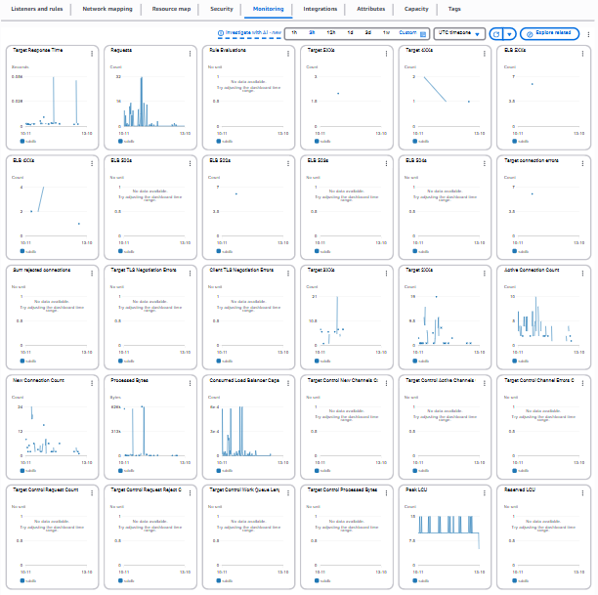

EC2 Instances
Monitoring
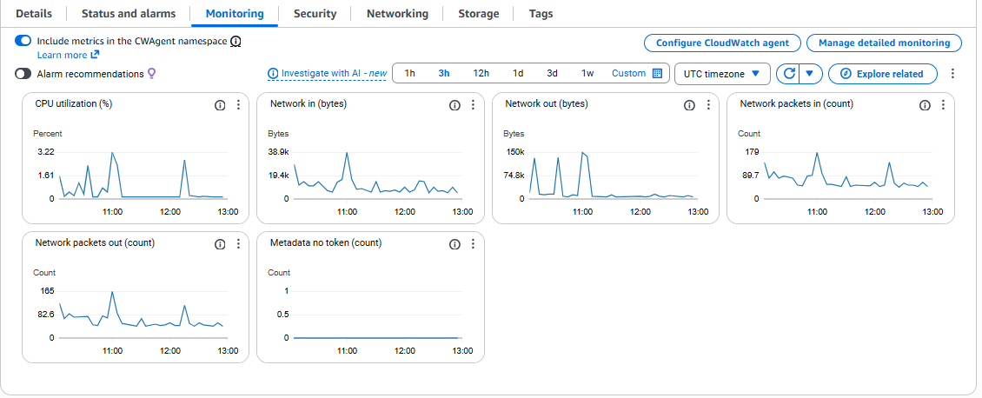

- RDS
PostgresSQL Instance
Monitoring
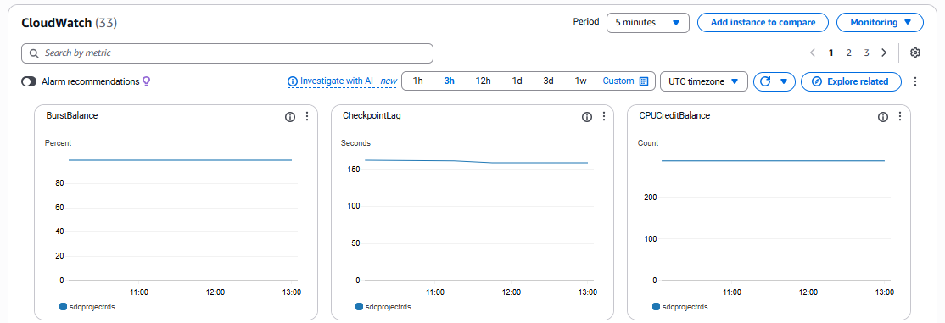
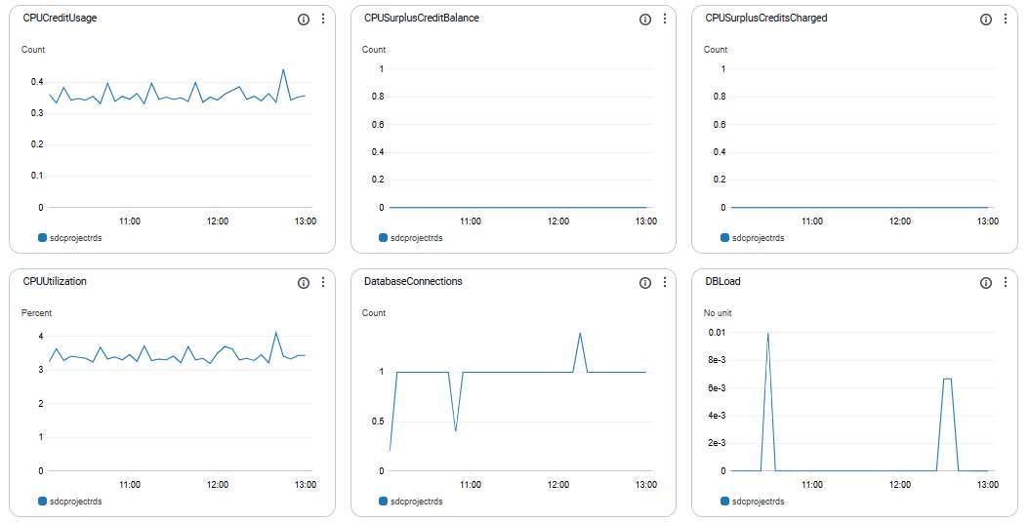
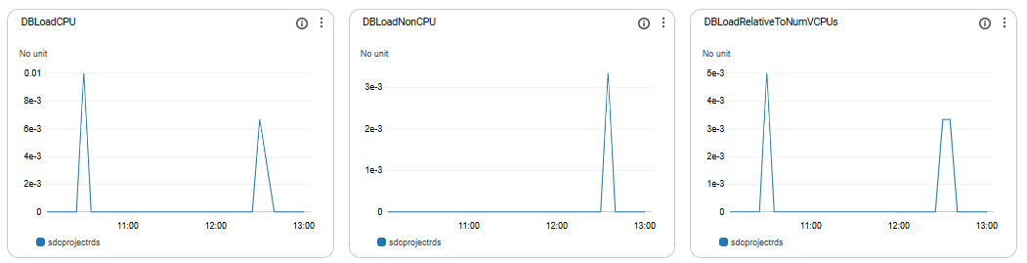

Logs
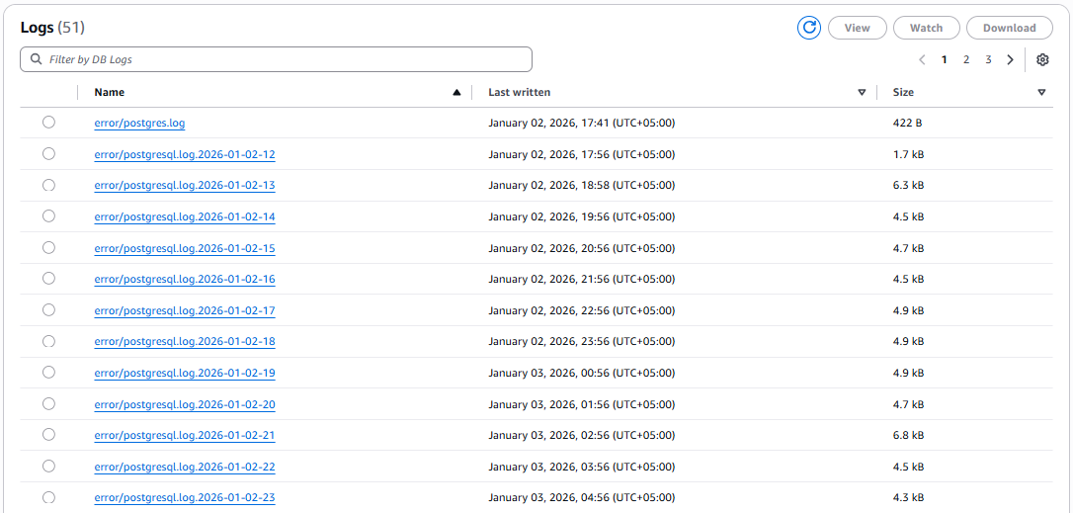
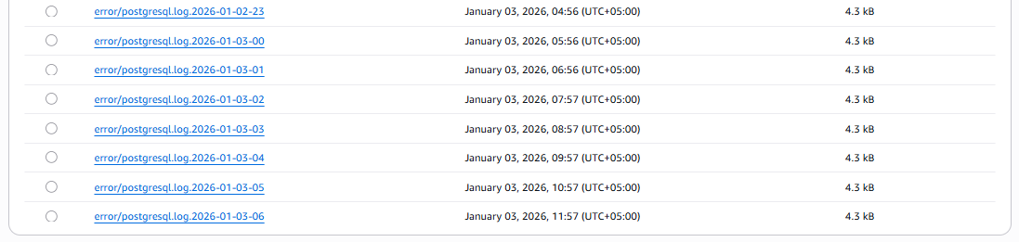
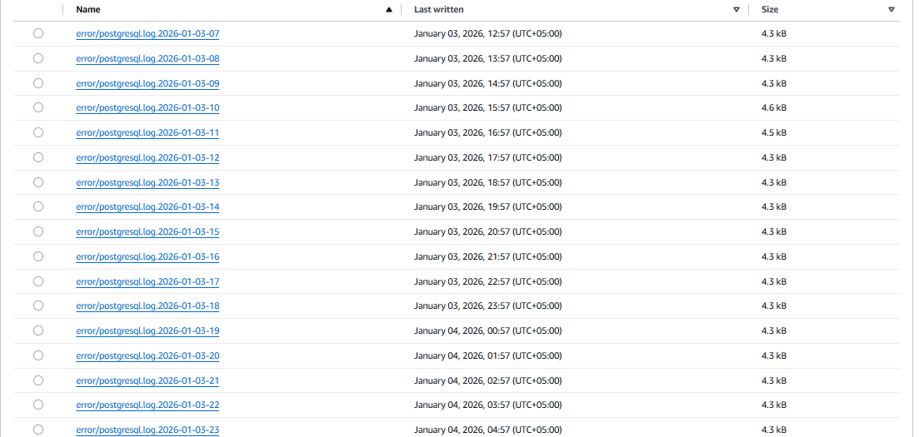
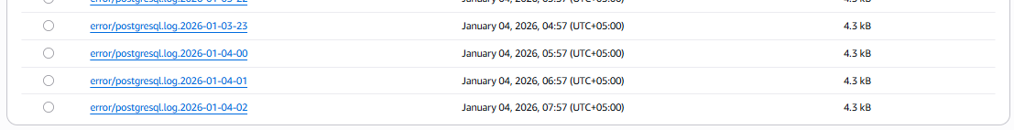

- Final output

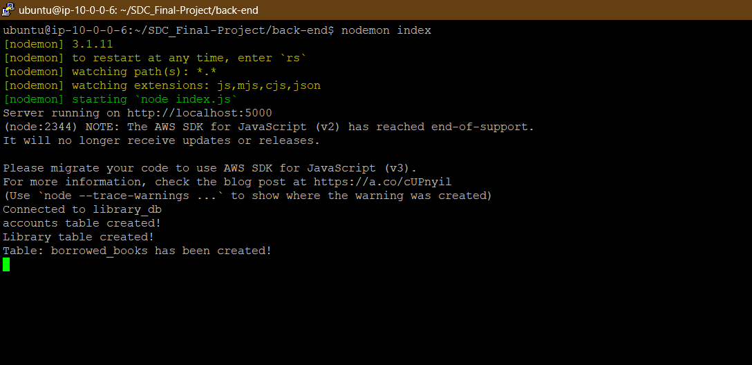
The backend server on EC2 instances is started using putty, then the load balancer directs the traffic to the backend

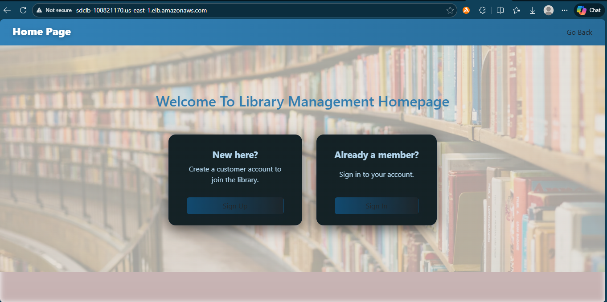
The homepage is accessible through the load balancer public dns

TECHNICAL REPORT (TOC, LOF, LOT, LOE & REFERENCES)

Group Work Proof

